GRADE 7 - SCIENCE
TERM 2 SUMMATIVE TEST 2

- A conservation program examines life at different levels, starting with individual cells and progressing to larger biological systems.
Which sequence correctly shows the levels of biological organization from smaller to larger?
- Cell → Organ → Tissue → Organism → Biosphere
- Tissue → Cell → Organ → Organism → Ecosystem
- Cell → Tissue → Organ → Organ System → Organism
- Organism → Organ System → Tissue → Ecosystem → Biosphere

- A marine research team studies a coral reef, beginning with the cells of a coral, then examining groups of cells, individual organisms, populations, communities, and finally the entire region where living organisms interact with their environment.
Which sequence best represents the progression from the smallest to the broadest level?
- Cell → Organism → Tissue → Population → Ecosystem → Biosphere
- Tissue → Cell → Organism → Community → Population → Biosphere
- Cell → Tissue → Organism → Population → Community → Ecosystem → Biosphere
- Cell → Organ → Organ System → Community → Ecosystem → Population → Biosphere

- A public health team investigates an infectious disease. They begin by examining groups of similar cells in affected tissue, then study an individual person, the people infected in a community, different populations interacting in the same area, and the interactions of these organisms with their surroundings. The investigation eventually considers all regions of Earth where living things exist.
Which sequence correctly arranges the levels represented in the investigation from simplest to most complex?
  - Tissue → Population → Organism → Community → Ecosystem → Biosphere
  - Tissue → Organism → Population → Community → Ecosystem → Biosphere
  - Tissue → Organism → Community → Population → Ecosystem → Biosphere
  - Organism → Tissue → Population → Community → Ecosystem → Biosphere

- A medical laboratory examines a tissue sample and observes that it is made up of many cells that perform related functions. The tissue is part of a larger structure with a specific role in the body.
Which relationship between the levels is shown by this example?
  - Tissues divide into separate organisms that perform different functions.
  - Larger structures develop first and later determine the functions of their cells.

  - Cells with related functions form tissues, which contribute to larger structures.
  - Individual cells perform all the functions of the larger structure independently.

- A patient experiences damage to a group of muscle cells. The affected cells belong to a tissue, which is part of an organ responsible for movement. The reduced function of the organ affects the movement of the whole body.
Which statement best explains what this example demonstrates about biological organization?
  - Changes at a lower level can influence the function of higher levels.
  - Each level maintains its function regardless of changes at lower levels.
  - Higher levels determine the structure of every lower level independently.
  - The functions of higher levels are unrelated to the activities of their components.

Items 6-7. Refer to the diagram below.
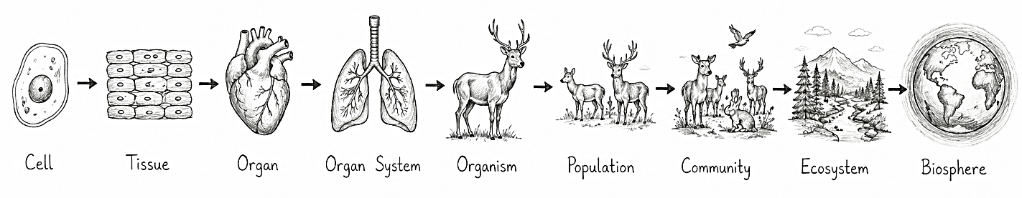
- Which statement best describes the relationship represented by the arrows?
  - Each level replaces the function of the level immediately below it.
  - Each level contains structures that are completely independent of one another.
  - Each lower level develops only after the higher level has already been established.
  - Each higher level is formed through the organization and interaction of components at lower levels.

- Which interpretation best explains why each level in the diagram depends on the level before it?
  - Each successive level contains the same components but simply occupies a larger physical area.
  - The levels represent separate biological units whose functions do not influence one another.
  - The characteristics of each level are determined only by the largest system in which it occurs.
  - Interactions among components at one level contribute to the structure and function of the next level.

- An environmental study organizes organisms in a grassland according to their feeding positions, placing producers at the bottom and higher-level consumers above them. The arrangement shows how organisms are positioned according to energy transfer.
What does a food pyramid represent in an ecosystem?
  - The movement of organisms between different habitats
  - The trophic levels and the available energy at each level
  - The number of species found in different ecosystems
  - The physical factors that control population growth

Items 9-12. Refer to the diagram below.
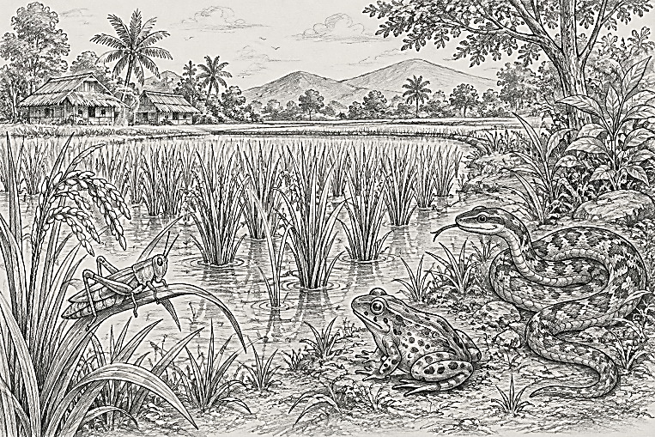

- The rice plants, grasshoppers, frogs, and snake shown in the diagram can be arranged according to their feeding positions.
Which sequence correctly represents their trophic levels from the first to the fourth level?
  - Rice plant → Frog → Grasshopper → Snake
  - Rice plant → Grasshopper → Frog → Snake
  - Rice plant → Snake → Grasshopper → Frog
  - Grasshopper → Rice plant → Frog → Snake

- Using the organisms shown in the diagram, a food pyramid is constructed from the organism that captures energy from the environment to the organism at the highest feeding position.
Which arrangement should be placed from the bottom to the top of the pyramid?
  - Rice plant → Frog → Grasshopper → Snake
  - Rice plant → Grasshopper → Frog → Snake
  - Rice plant → Grasshopper → Snake → Frog
  - Grasshopper → Rice plant → Frog → Snake

- In the food relationship shown in the diagram, the frog feeds on the grasshopper, which feeds on rice plants.
Which trophic level does the frog occupy?
  - First trophic level
  - Fourth trophic level
  - Second trophic level
  - Third trophic level

- Suppose researchers are recording the feeding positions of the organisms shown in the rice-field ecosystem. They identify the snake as the organism that feeds on the frog.
Based on its position in the food chain, which trophic level does the snake occupy?
  - First trophic level
  - Fourth trophic level
  - Second trophic level
  - Third trophic level

Items 13-16. Refer to the scenario below.
Marine scientists are studying a coastal ecosystem where phytoplankton are eaten by zooplankton, zooplankton are eaten by small fish, and small fish are eaten by tuna. Phytoplankton obtain energy from sunlight, while each group of consumers obtains energy by feeding on the level below it.

- Which statement best describes how energy moves through this marine food chain?
  - Small fish convert energy from tuna into energy for zooplankton.
  - Zooplankton produce energy that is transferred to phytoplankton.
  - Phytoplankton capture energy that becomes available to organisms that feed on them.
  - Tuna provides energy that moves downward to the phytoplankton and upward to the small fish.

- The scientists find that the amount of available energy is greatest among the phytoplankton.
What pattern would they expect as they move from phytoplankton toward tuna?
  - The available energy remains equal across all levels.
  - The available energy becomes greater at each level.
  - The available energy increases after each feeding interaction.
  - The available energy becomes smaller at higher trophic levels.

- The scientists estimate that the phytoplankton contain 20,000 energy units. If approximately 10% of the available energy is transferred to the next trophic level, how much energy would reach the small fish?
  - 2 units
  - 20 units
  - 200 units
  - 2,000 units

- The scientists observe that the ocean contains abundant phytoplankton but supports far fewer tuna. They relate this pattern to the energy available at each trophic level.
Which explanation best accounts for this observation?
  - Tuna requires less energy because they occupy a higher trophic level.
  - Phytoplankton use less energy because they are the smallest organisms.
  - Only part of the energy at one trophic level becomes available to the next level.
  - Energy becomes more concentrated as it moves toward higher consumers.

- A coastal ecosystem contains phytoplankton, zooplankton, small fish, and tuna. Scientists estimate that only a fraction of the energy available at one trophic level is transferred to the next. The energy values are:
Trophic Level | Organism | Available Energy
1 | Phytoplankton | 20,000 units
2 | Zooplankton | 2,000 units
3 | Small fish | 200 units
4 | Tuna | 20 units
Which conclusion best explains why the organisms are arranged into these trophic levels in the food pyramid?
- Energy is divided equally among organisms as feeding moves upward.
- Higher levels contain fewer organisms because their bodies are larger.
- Each level contains organisms with progressively greater energy needs.
- Each level represents a feeding position with less available energy than the level below it.

Items 18-20. Refer to the forest food pyramid diagram below.
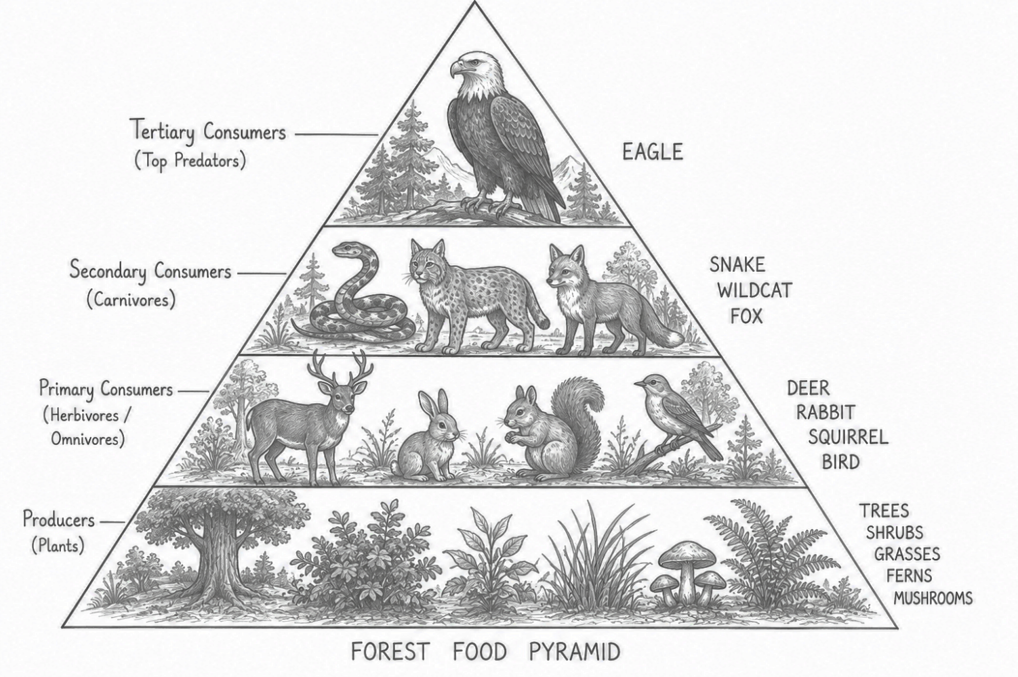
- In the forest food pyramid, the eagle is placed at the top. What trophic level does the eagle represent?
  - Producer
  - Primary consumer
  - Secondary consumer
  - Tertiary consumer

- An owl is added to the forest food pyramid. If the owl is placed at the same trophic level as the eagle in the diagram, which trophic level should the owl be assigned to?
  - Producer level
  - Primary consumer level
  - Secondary consumer level
  - Tertiary consumer level

- A forest food pyramid shows that energy moves from:
plants → herbivores → carnivores → top predators.
Suppose a large number of plants in the forest suddenly die because of a drought. Which change would most likely happen first in the food pyramid?
- The eagle would immediately receive more energy.
- The herbivores would have less energy available to obtain.
- The carnivores would produce more energy for the herbivores.
- The plants would receive more energy from the animals above them.

- A student traces the energy flow in the forest food pyramid and notices that less energy is available at each higher trophic level. If the number of rabbits decreases greatly, which change would most likely occur in the organisms that depend on rabbits for food?
  - They would have less energy available to them.
  - They would receive more energy from the plants.
  - They would produce more energy for the rabbits.
  - They would transfer more energy back to the plants.

- In the forest food pyramid, plants have the greatest amount of available energy. Only a small portion of this energy is transferred to the next trophic level. If the plants have 10,000 units of energy, approximately how much energy can be transferred to the third trophic level?
  - 10 units
  - 100 units
  - 1,000 units
  - 10,000 units

Items 23-25. Refer to the three (3) food pyramids below.
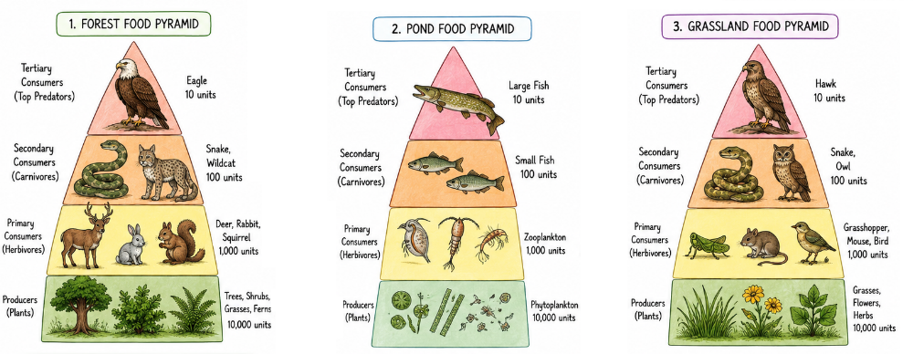

- The three food p
- yramids show different ecosystems. In each pyramid, only about 10% of the energy is transferred to the next trophic level. Which statement correctly compares the energy available to the secondary consumers in the three pyramids?
  - Secondary consumers receive 10 units because energy is reduced by 10% at every trophic level.
  - Secondary consumers receive more energy in the pond because fish use energy more efficiently.
  - All secondary consumers receive the same amount of energy because they occupy the same level.
  - Secondary consumers receive about 100 units because 10% of the primary consumers' energy is transferred.

- In the forest food pyramid, the producers contain 10,000 units of energy. A student claims that the eagle receives 1,000 units because it is a consumer. Based on the diagram, which response best corrects the student's claim?
  - The claim is correct because the eagle receives energy directly from the plants.
  - The claim is correct because all consumers receive 10% of producer energy.
  - The claim is incorrect because only about 10% is transferred at each trophic level.
  - The claim is incorrect because energy increases as organisms move toward the top.

- A drought reduces the producers in the grassland food pyramid from 10,000 units to 5,000 units of energy. Assuming the same 10% energy transfer continues at each level, what would most likely happen to the energy available to the secondary consumers?
  - It would decrease from 100 units to 5 units.
  - It would decrease from 100 units to 50 units.
  - It would increase from 100 units to 500 units.
  - It would remain at 100 units because trophic level stays the same.

